
YISHUN INNOVA JUNIOR COLLEGE
JC 2 PRELIMINARY EXAMINATION
Higher 1

CANDIDATE
NAME

CG |  |  |  |  |  |  | INDEX NO

GEOGRAPHY  Paper 1  INSERT | 8834/01 (REVISED)  27 August 2024  3 hours

READ THESE INSTRUCTIONS FIRST
This Insert contains all the Resources referred to in the questions.

INSERT

This document consists of 9 printed pages and 1 blank page.

Resource 1 for Question 1

Photograph of a location in Serangoon North identified to conduct the fieldwork

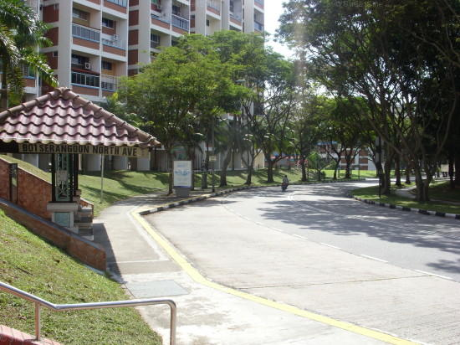

Resource 2 for Question 1

Questionnaire used by students for the survey

Questionnaire
Personal information:
- Age: 65 – 74 75 - 84 Above 84
- Gender: Male Female
- Do you live in the Serangoon North estate: Yes No
- How long have you lived in this area? __________________
- Do you find your transport needs met? Please indicate how satisfied you are with the transport needs on a scale of 1 to 5 where 1 is not satisfied and 5 very satisfied.
Transport Need  Public transport (bus, MRT etc)  Frequency of Public transport  Safety on public transport service  Quality of footpaths and crossings  Other forms of transport (ride-sharing, car-sharing scheme)  Availability of transport options in times of emergency | Not satisfied  1  1  1  1  1  1 | 2  2  2  2  2  2 | 3  3  3  3  3  3 | 4  4  4  4  4  4 | Very satisfied  5  5  5  5  5  5
- What do you see as the two biggest advantages of the transport facilities in this neighbourhood?

a._________________________________________________
b. _________________________________________________

Thank you for your time.

Resource 3 for Question 1
Results of the questionnaire survey done on 80 elderly persons
who are most satisfied with the transport needs

 | By age group | Total number
Public transport (bus, MRT etc) | 65-74 | 24
Public transport (bus, MRT etc) | 75-84 | 12
Public transport (bus, MRT etc) | Above 84 | 2
Frequency of Public transport | 65-74 | 20
Frequency of Public transport | 75-84 | 10
Frequency of Public transport | Above 84 | 2
Safety on public transport service | 65-74 | 18
Safety on public transport service | 75-84 | 9
Safety on public transport service | Above 84 | 2
Quality of footpaths and crossings | 65-74 | 23
Quality of footpaths and crossings | 75-84 | 11
Quality of footpaths and crossings | Above 84 | 2
Other forms of transport (ride-sharing, car-sharing scheme) | 65-74 | 12
Other forms of transport (ride-sharing, car-sharing scheme) | 75-84 | 2
Other forms of transport (ride-sharing, car-sharing scheme) | Above 84 | 0
Other forms of transport (ride-sharing, car-sharing scheme) | No Data | 10
Availability of transport options in times of emergency | 65-74 | 3
Availability of transport options in times of emergency | 75-84 | 6
Availability of transport options in times of emergency | Above 84 | 1
Availability of transport options in times of emergency | No data | 7

Resource 4 for Question 2
Photographs of 798 Art District

Resource 4A
798 Art District before reimaging

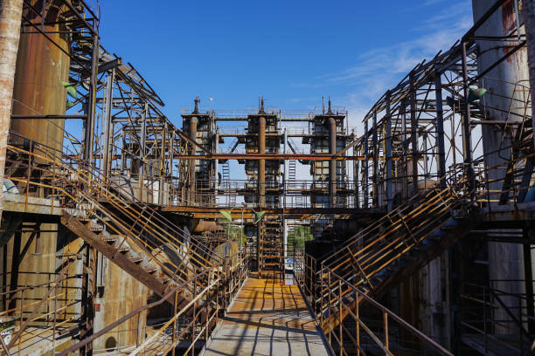

Resource 4B
798 Art District after reimaging

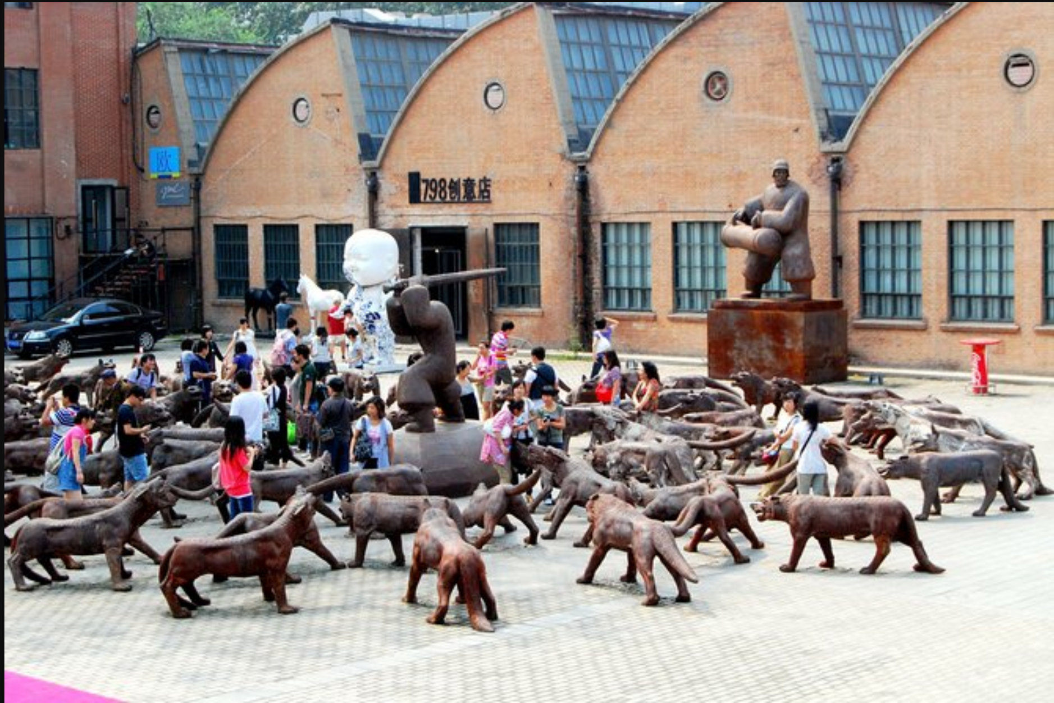

Resource 5 for Question 2

Map of Beijing

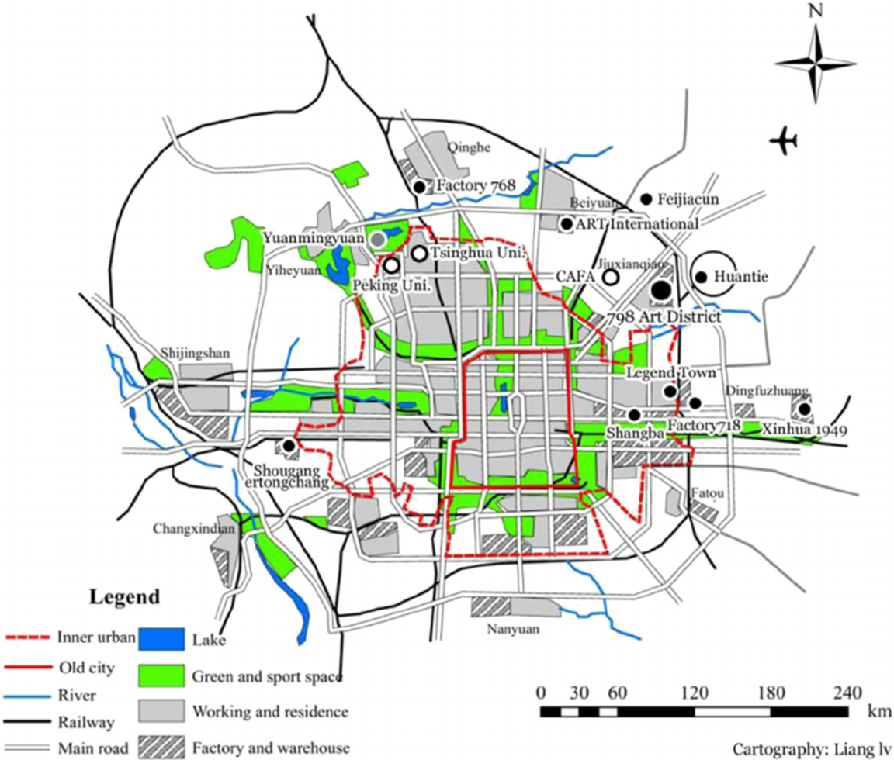

Resource 6 for Question 2

Employment structure of cultural and creative industries in Beijing
(in thousands)

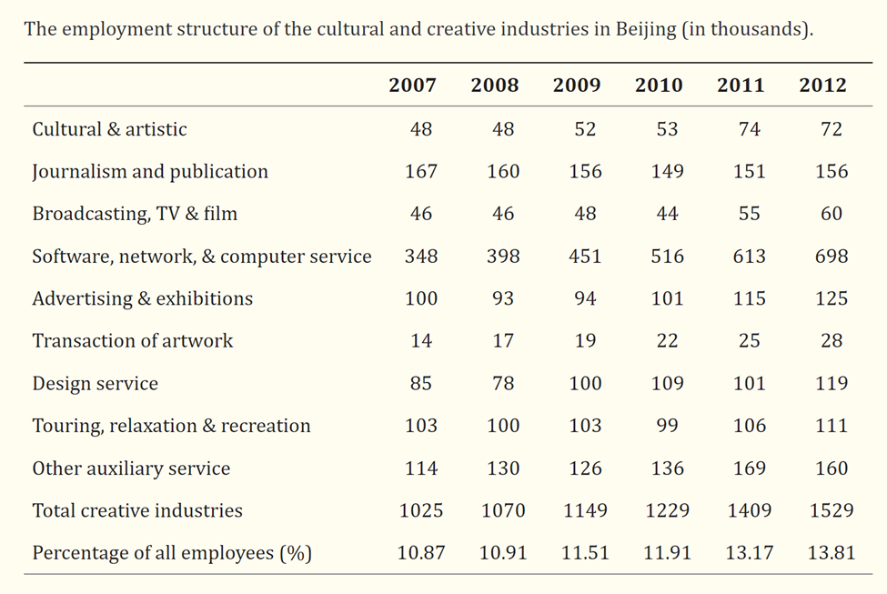

Resource 7 for Question 1
Interview extract with an artist who arrive at 798 District before 2005
The rent has risen too fast in the recent past, many art institutions and shops have left for other creative parks, and many shops have frequently changed their owner. I know the rent of some places is now 8 Yuan/m2/day. It is too expensive for us. If I did not rent this workshop as early as 2004, and if my rent contact was not as long as ten years, it would also be difficult for me to remain in Factory 798. But my contract is running out. I must seek a new place in the next year (Interview, November 2013).

Resource 8 for Question 2
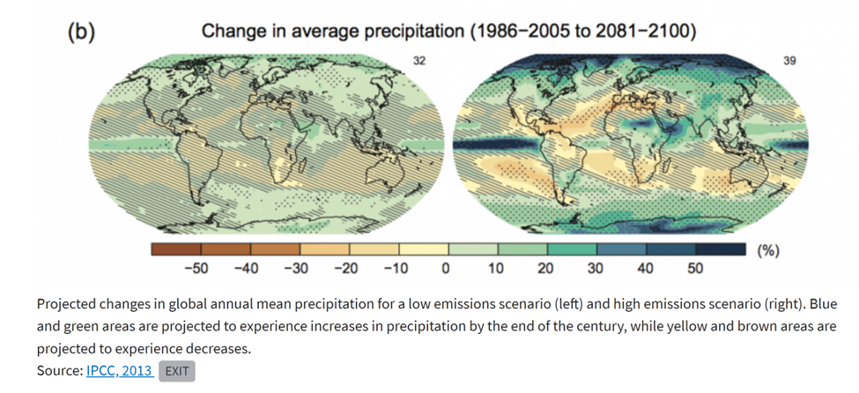

Resource 9 for Question 3

Impacts of climate change on India

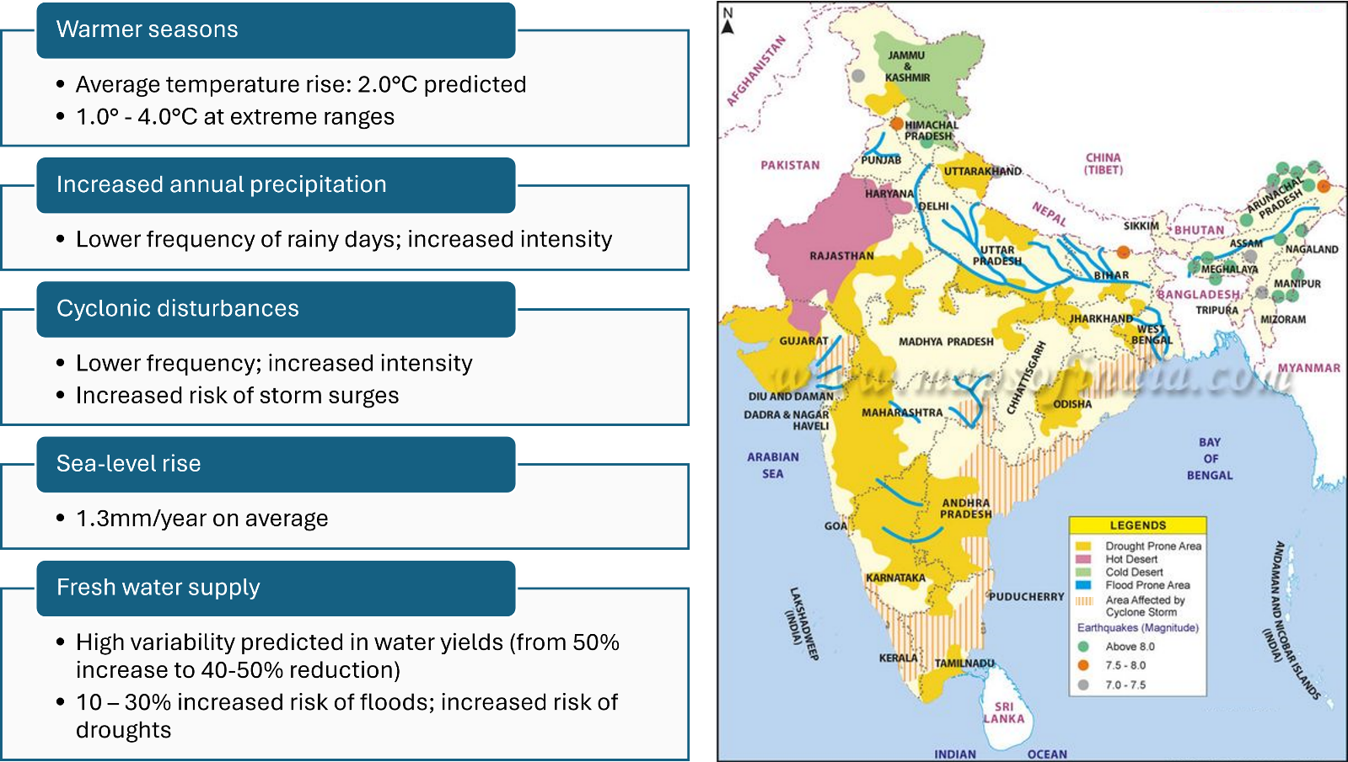

Resource 10 for Question 3

Carbon dioxide emissions per person

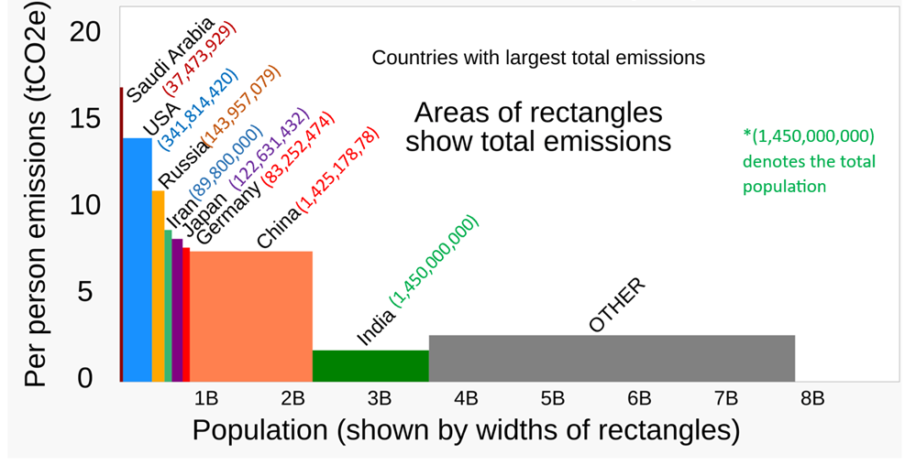

Resource 11 for Question 3

U.S.-India partnership leads on climate crisis
reported by Leigh Hartman on May 9, 2024

The U.S.-India partnership on climate change leads by example and offers a blueprint for how countries can address climate change.

By combining their resources, expertise, and leadership, the world’s oldest and world’s largest democracies are not only advancing their own clean energy goals but also set a powerful example.

“We have an extraordinary partnership between the United States and India that has grown stronger and stronger in recent years, stronger than it’s ever been,” Secretary of State Antony Blinken said when he met with Indian External Affairs Minister Subrahmanyam Jaishankar in February. “It is for us among the most consequential relationships of any in the world.”

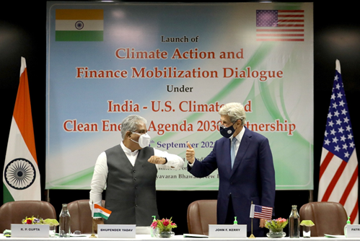

Source: https://share.america.gov/u-s-india-partnership-leads-on-climate-crisis/

BLANK PAGE

